**DATE: June 26, 2019**

**OPERATIONS MEMORANDUM #19-06-01**

**SUBJECT:** Conditional Medicare Part A Buy-In for Qualified Medicare Beneficiaries

**TO:** Executive Directors

**FROM:** Inez Titus

Director

Bureau of Operations

**PURPOSE**

To inform County Assistance Offices (CAOs) that individuals who lack Medicare Part A and intend to apply for Buy-In coverage as a Qualified Medicare Beneficiary (QMB) may “conditionally enroll” in Part A and provide instructions on how to identify conditional Part A and process the Buy-In benefit.

**BACKGROUND**

Although most Medicare beneficiaries qualify for “Premium-free Part A,” a minority lack the requisite work history and can only enroll in “Premium-Part A.” Many such individuals, however, cannot afford to pay the Medicare Part A premium (up to $437 each month in 2019) without assistance.

The state’s Buy-In program helps pay the Part A premium in addition to the Part B premium and Parts A and B cost-sharing for individuals enrolled as a QMB. However, an individual must be enrolled in Part A to meet the non-financial requirements for Buy-In as a QMB. This creates an impossible predicament for low-income individuals who are only eligible for Premium-Part A but cannot afford to enroll in it.

**DISCUSSION**

The Social Security Administration (SSA) has clarified their policy which allows low-income individuals who lack Premium-free Part A to “conditionally enroll” in Premium-Part A. The conditional enrollment process allows individuals to apply for Premium-Part A at SSA but only get the coverage if the state approves their QMB application, whereby the state will pay the Part A premiums.

With conditional enrollment in Medicare Part A, individuals meet the eligibility criteria for the QMB program, enabling the state to find them eligible for Buy-In and begin paying the Part A premiums. If the state denies the QMB application, the individual will not be enrolled in Premium-Part A.

As part of the conditional enrollment process, SSA requires individuals to also apply for Part B if they are not already enrolled in it. Part B coverage begins regardless of whether the state approves the individual’s QMB application. If the individual is ineligible for QMB and does not wish to pay Part B premiums, they may withdraw from Part B coverage.

**PROCEDURES**

When processing conditional Part A enrollment, SSA will refer the individual to the CAO to apply for the Buy-In program and may give the individual a screen shot of the SSA application to bring to the state as proof of the conditional enrollment. The CAO can also query SSA’s Master Benefit Record (BENDEX-MBR) on Exchange 3 to verify the conditional Part A enrollment.

**Verification of Conditional Enrollment on BENDEX**

Conditional Part A enrollment verification is found in two locations on an individual’s BENDEX-MBR Match Details record:

1. The **Status** tab will show Part A entitlement with Payer code ‘Z99’. Hover over the Z99 code and the description “Conditional State Group Payer” will appear.

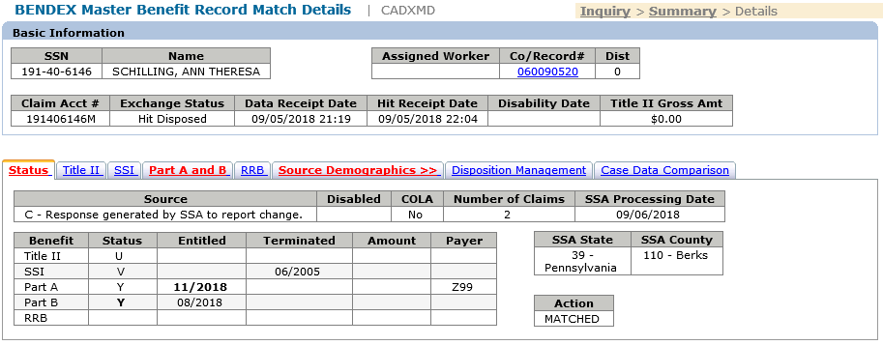

1. The **Part A and B** tab will show Buy-In Category ‘Q – QMB Conditional’ and a Buy-In Begin date. This is the date that Part A Buy-In may begin.

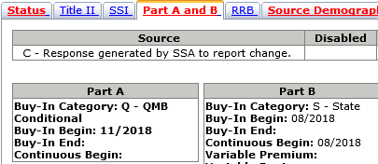

**Conditional QMB Enrollment Process**

When Part A coverage with Payer ‘Z99’ is shown on the BENDEX-MBR screen, this indicates the individual has been authorized Part A on the condition that they are eligible for Buy-In as a QMB; however, they have not been enrolled in Part A Buy-In.

**Important:** The CAO must enroll the individual in Buy-In to activate the Part A coverage. Conditional Part A recipients are not eligible for auto-accrete and must be enrolled in Buy-In through manual accrete processing.

To enroll a Conditional QMB recipient in Part A Buy-In, the CAO will take the following actions:

1. Confirm the recipient is eligible for Buy-In in a QMB program in eCIS. If the individual is not currently active as a QMB, run eligibility to authorize them in the appropriate QMB program. See Medical Assistance Eligibility Handbook (MAEH) Section 388.2 for QMB state coverage groups.
2. Review the Exchange 3 BENDEX-MBR to confirm the recipient is enrolled in Part B Buy-In. As a QMB, the individual is entitled to Buy-In of both Part A and B, but Part B must be authorized first. If the individual does not already have Part B Buy-In, or was just authorized in a QMB program, the CAO must manually accrete them before requesting Part A Buy-In. See the Exchanges section of eCIStance for guidance on how to process a manual accrete.
3. Confirm the recipient’s Conditional Part A Begin Date by reviewing the Part A and B tab on BENDEX-MBR.
4. Process the Part A manual accrete by accessing the Exchanges Buy-In Request screen and completing the fields under the ‘Request to CMS’ section as follows:
   * Check the ‘Select’ box for the first row.
   * Select Part A from the ‘Type’ drop-down.
   * Select 61 – Accrete (Start/Open Buy-In) from the ‘Transaction Code’ drop-down.
   * Complete the ‘From Date’ field using the Part A Buy-In Begin Date from BENDEX-MBR Part A and B tab.

**NOTE:** The Part A Buy-In begin date cannot be earlier than the month Part B entitlement began.

Following the manual accrete, the CAO will check the Buy-In Action History screen to confirm it was accepted by the Centers for Medicare and Medicaid Services (CMS). CMS may take a few days to return an ‘1161’ response indicating acceptance. Once CMS accepts the accrete and updates the recipient’s MBR, the Part A Payer will change from ‘Z99’ to ‘390 (PA)’ on the BENDEX-MBR. Part A will then be added to the Third-Party Liability (TPL) section in eCIS via CAO entry or monthly batch process.

**Important:** An individual who has Part A entitlement with Payer ‘Z99’ does not have Part A coverage until Buy-In begins. Do not check the “Medicare Part A Recipient” box on the Individual Attributes screen or create a TPL screen for Part A coverage until the Part A Payer has changed to ‘390’ on the BENDEX-MBR.

**NEXT STEPS**

1. Share and review this information with appropriate staff members.
2. Handbooks will be updated. Current policy in MAEH Chapter 388 will be updated to reflect this information.
3. Please contact your area manager if you have questions regarding this Operations Memorandum.